Матрица 1

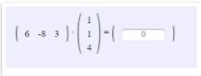

Решение:

6 * 1 + (-8) * 1 + 3 * 4 = 6 – 8 + 12 = 10

Ответ: 10

Матрица 2

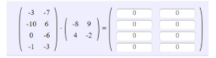

Решение:

|  |  |
| --- | --- |
| -3 * (-8) + (-7) * 4 = 24 – 28 = -4 | -3 * 9 + (-7) * (-2) = -27 + 14 = -13 |
| -10 * (-8) + 6 * 4 = 80 + 24 = 104 | -10 * 9 + 6 * (-2) = -90 – 12 = -102 |
| 0 * (-8) + (-6) * 4 = 0 – 24 = -24 | 0 * 9 + (-6) * (-2) = 0 + 12 = 12 |
| -1 * (-8) + (-3) * 4 = 8 – 12 = -4 | -1 * 9 + (-3) * (-2) = -9 + 6 = -3 |

Ответ:

|  |  |
| --- | --- |
| -4 | -13 |
| 104 | -102 |
| -24 | 12 |
| -4 | -3 |